PROJECT

DATA VISUALISATION (3860 – 070)

SUBMITTED TO: SUBMITTED BY:

RUPA MANABALA PRITHVI CHAVHAN

300357826

chavhanp@student.douglascollege.ca

**DETAILS OF THE DATASET**

**NEW DATASET:** Adidas Sales Dataset

**LINK:** https://www.kaggle.com/datasets/heemalichaudhari/adidas-sales-dataset

**DATA DESCRIPTION:**

An Adidas sales dataset is a collection of data that includes information on the sales of Adidas products. This type of dataset may include details such as the number of units sold, the total sales revenue, the location of the sales, the type of product sold, and any other relevant information.

Adidas sales data can be useful for a variety of purposes, such as analyzing sales trends, identifying successful products or marketing campaigns, and developing strategies for future sales. It can also be used to compare Adidas sales to those of competitors, or to analyze the effectiveness of different marketing or sales channels.

There are a variety of sources that could potentially provide an Adidas sales dataset, including Adidas itself, market research firms, government agencies, or other organizations that track sales data. The specific data points included in an Adidas sales dataset may vary depending on the source and the purpose for which it is being used.

**NUMBER OF FIELDS AND ROWS:** 9652 Rows and 14 Fields

**PART – A**

**TABLEAU**

**DOCUMENTATION ON THE VISUALS**

**INTRODUCTION**

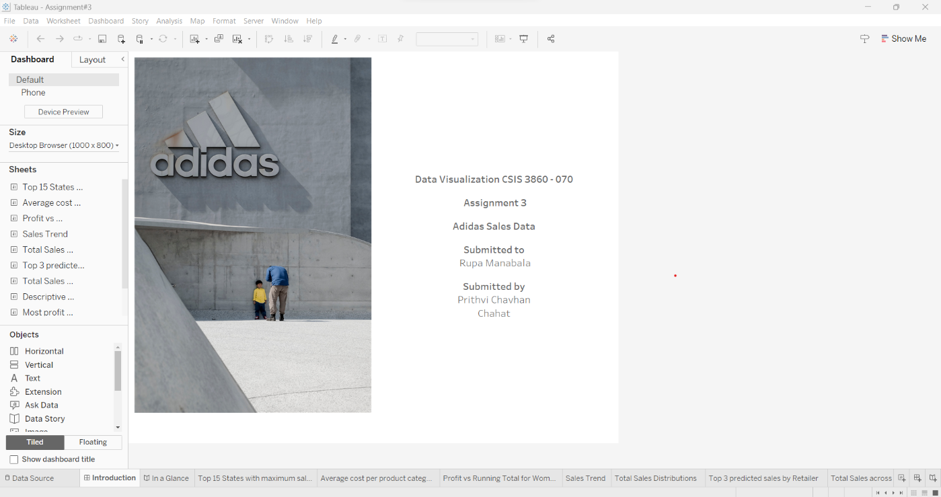

Figure 1

This is an introductory dashboard at the very beginning of the workbook.

**IN A GLANCE – STORY REPRESENTATION**

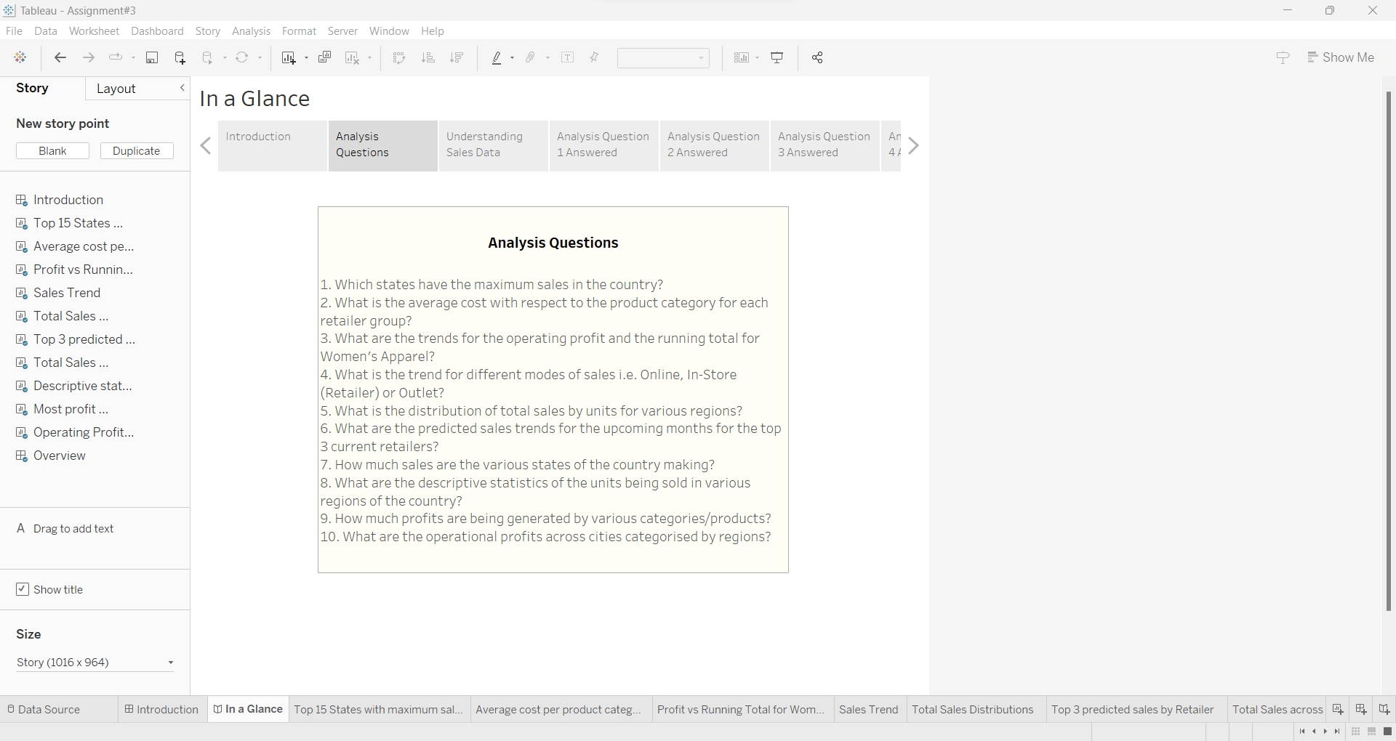

Figure 2

In a Glance is the representation of the workbook in a story format. It includes an Introduction story followed by Analysis Questions, Visuals and Conclusion.

1. **TOP 15 STATES WITH MAXIMUM SALES**

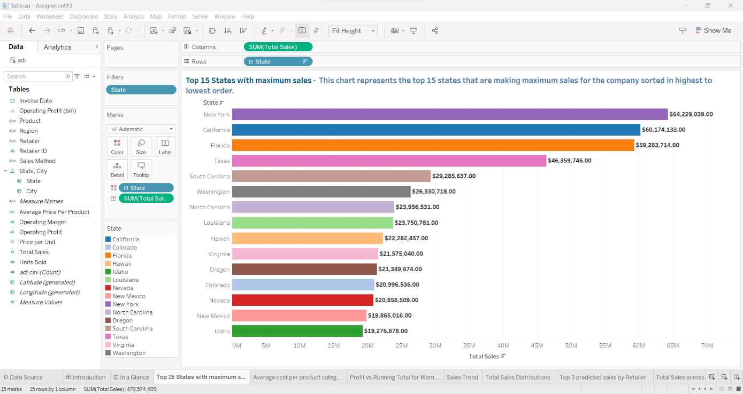

Figure 3

This visual depicts a horizontal bar graph wherein the top 15 states that are making the highest sales are portrayed in descending order. With the sum of Total Sales on the columns and States on the rows, a filter has been applied on the states to just display the top 15. Then, sorting has been applied to preview the bars in a highest to lowest order.

1. **AVERAGE COST PER PRODUCT CATEGORY BY RETAILER GROUP**

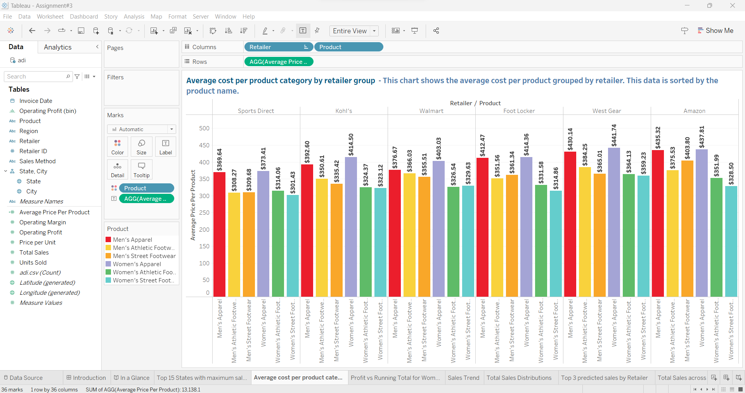

Figure 4

A vertical bar chart that displays the average cost per product with respect to each retailer. Retailer and Product are put onto columns. The calculated field is created called – Average Price per Product. It is created as follows:

AVG([Total Sales])/AVG([Units Sold])

This is put on rows to generate the shown visual.

1. **PROFIT VS RUNNING TOTAL FOR WOMEN'S APPAREL**

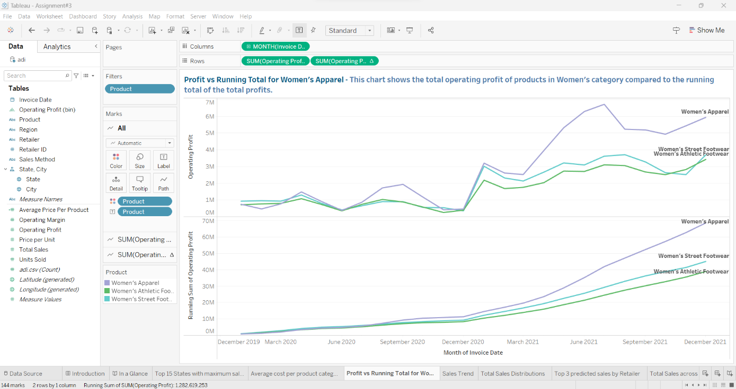

Figure 5

The line chart shows the Total Operating Profit of products in Women’s category versus the Running Total of the Total Profits. The month from the invoice date is put on the columns and sum of operating profit and the table calculation of sum of operating profit (running total) on the rows.   
A filter has been applied to the Product attribute to just display the Women’s Category and filter out the Men’s.

1. **SALES TREND**

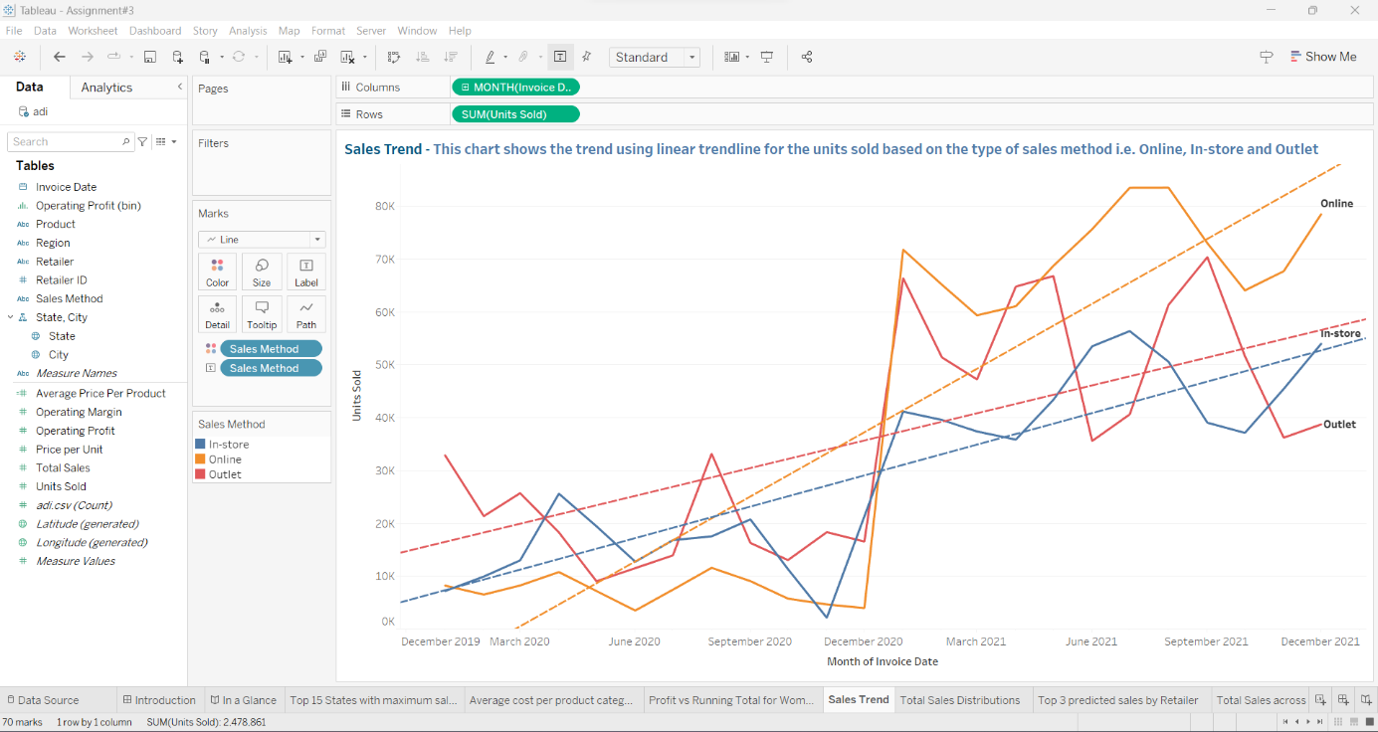

Figure 6

A visual is created to visualise the trendlines (linear) for the units sold for every method of sales – Online, In-store and Outlet. The month from invoice date has been put on columns and sum of units sold on rows.

1. **TOTAL SALES DISTRIBUTIONS**

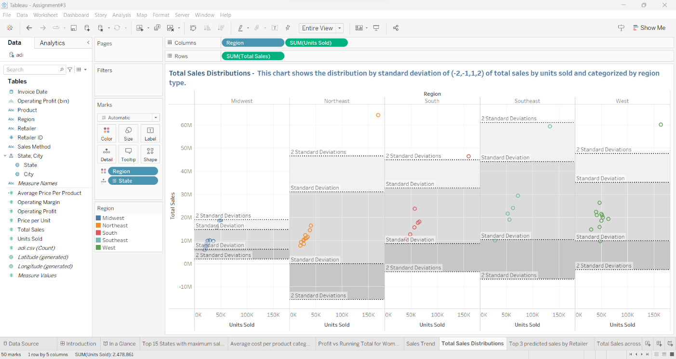

Figure 7

The chart shows the total sales by units sold with the categorisation of the regions. Region and sum of units sold is on columns and sum of total sales on rows. A distribution band has been put on the cell for standard deviation of (-2,-1,1,2).

1. **TOP 3 PREDICTED SALES BY RETAILER**

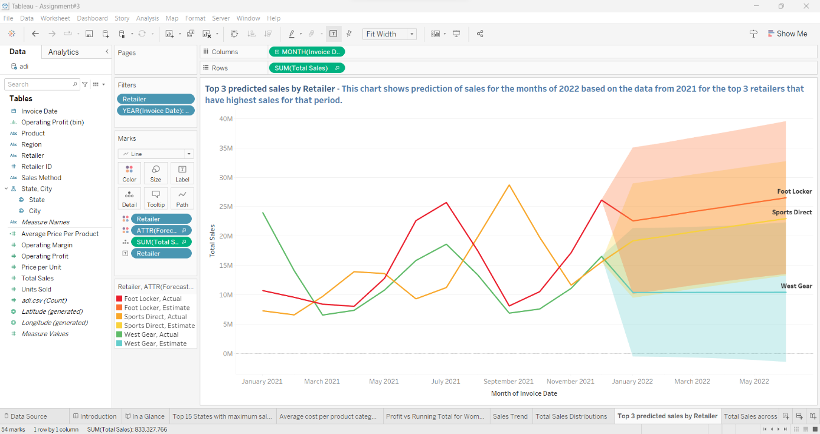

Figure 8

The visual shows the sales for the months of 2021 for top three retailers. Based on this data, a prediction has been made for the expected trend for the months of 2022 as well. This is achieved using forecasting method. Month from the invoice date is on columns and sum of total sales on rows.

1. **TOTAL SALES ACROSS STATES**

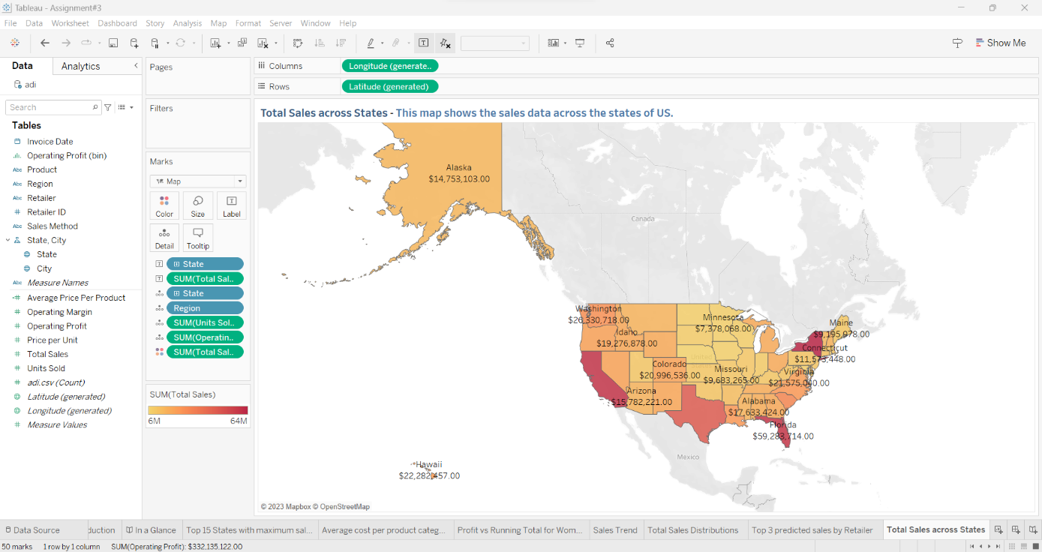

Figure 9

The visual shows the sales for the various states of the country in a geographical map format.

1. **DESCRIPTIVE STATS FOR UNITS SOLD**

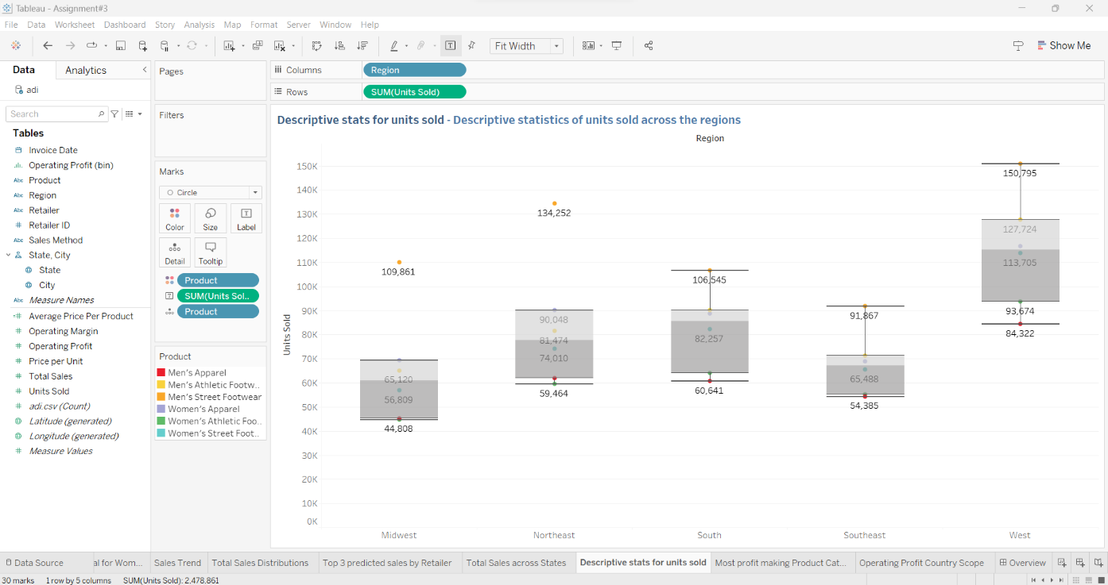

Figure 10

The visual shows the descriptive statistics for the units sold in various regions of the country through the means of boxplots.

1. **MOST PROFIT-MAKING PRODUCT CATEGORIES**

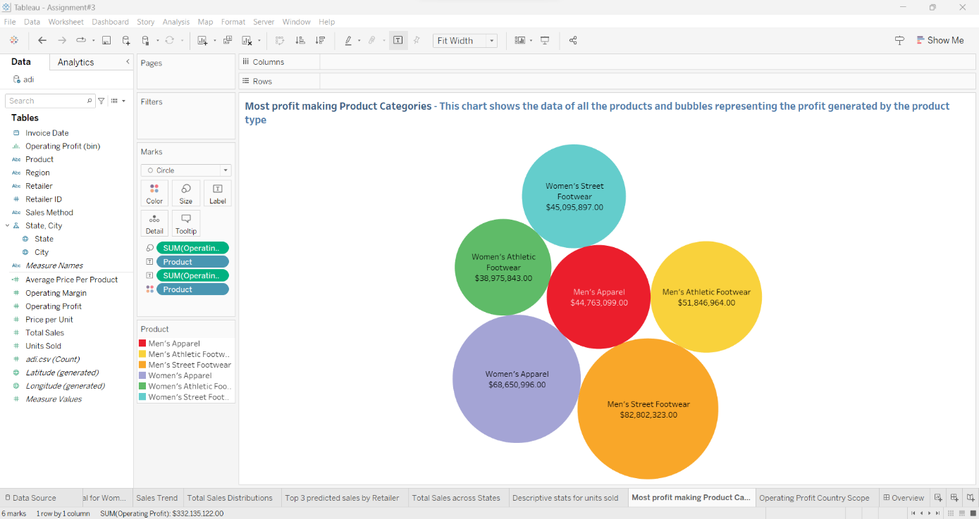

Figure 11

The visual shows the profits being generated for various product categories through a bubble chart.

1. **OPERATING PROFIT COUNTRY SCOPE**

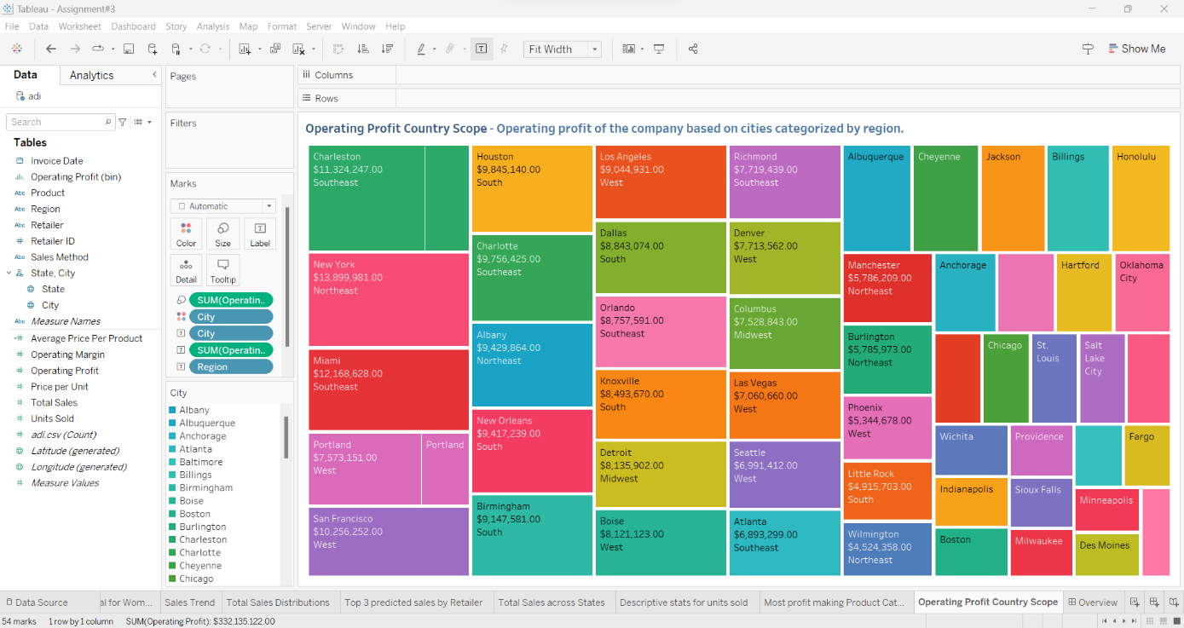

Figure 12

The visual shows the operating profit for the companies based on the various cities of the country categorised by the regions by the means of a tree map.

**OVERVIEW - DASHBOARD**

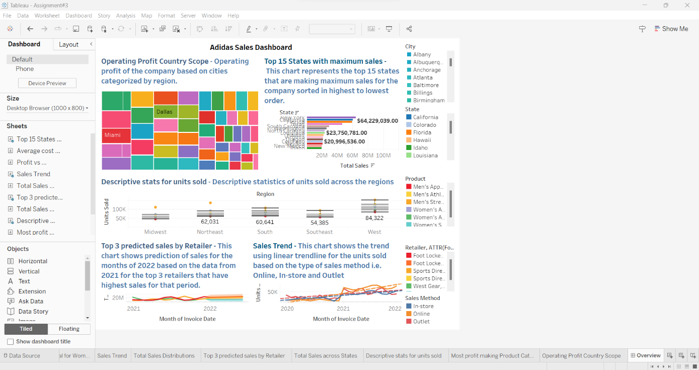

Figure 13

The Overview is a dashboard representation of the workbook with the visuals and their respective legends on the right.

**PART – B**

**POWER BI**

**DOCUMENTATION ON THE VISUALS**

Figure 14

Tabular View in Power BI

Figure 15

Relationship View in Power BI

1. **Top 15 cities with maximum profits**

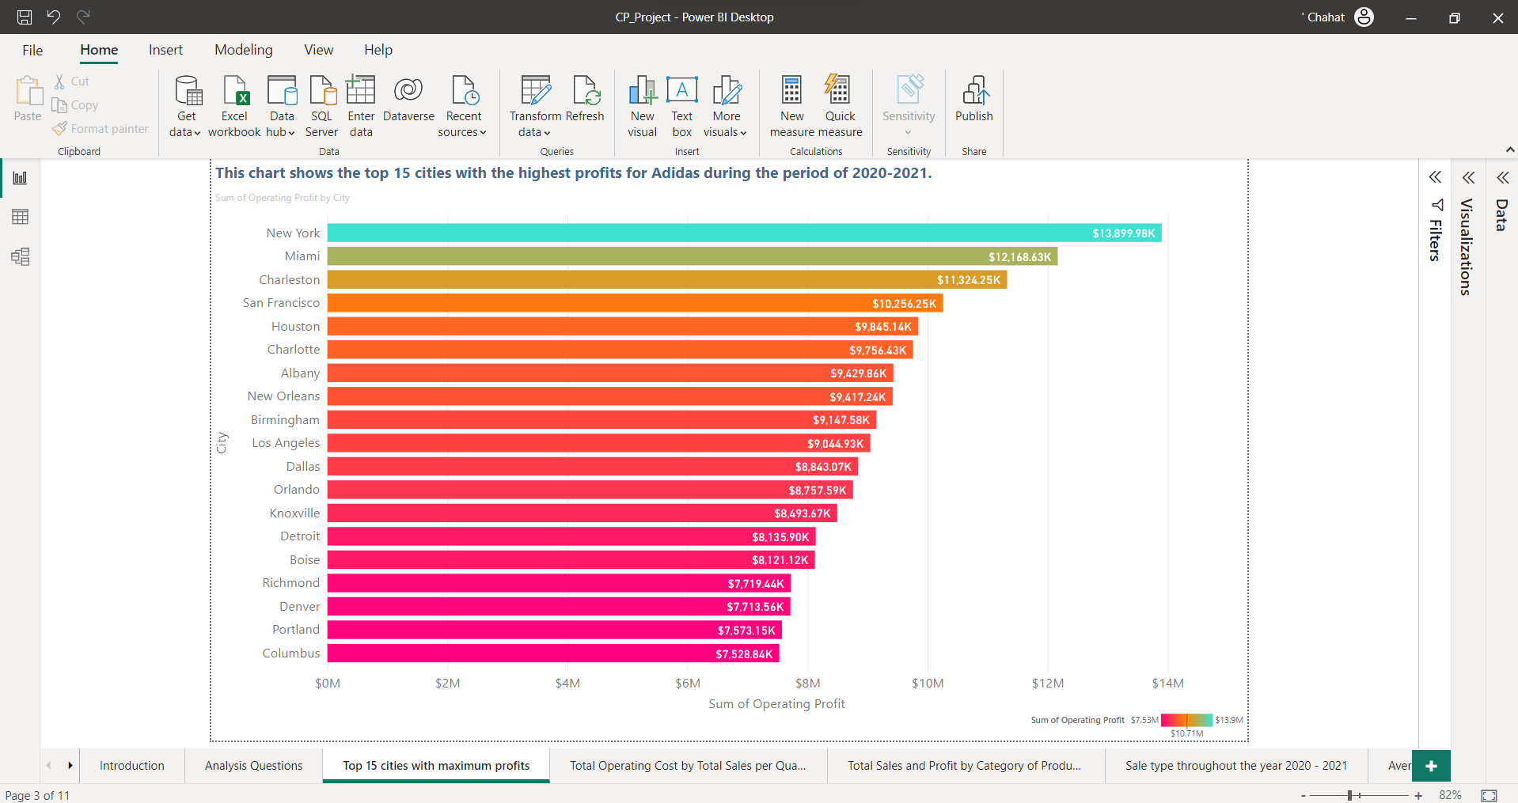

Figure 16

This chart shows the top 15 cities with the highest profits for Adidas during the period of 2020-2021.

1. **Total Operating Cost by Total Sales per Quarter**

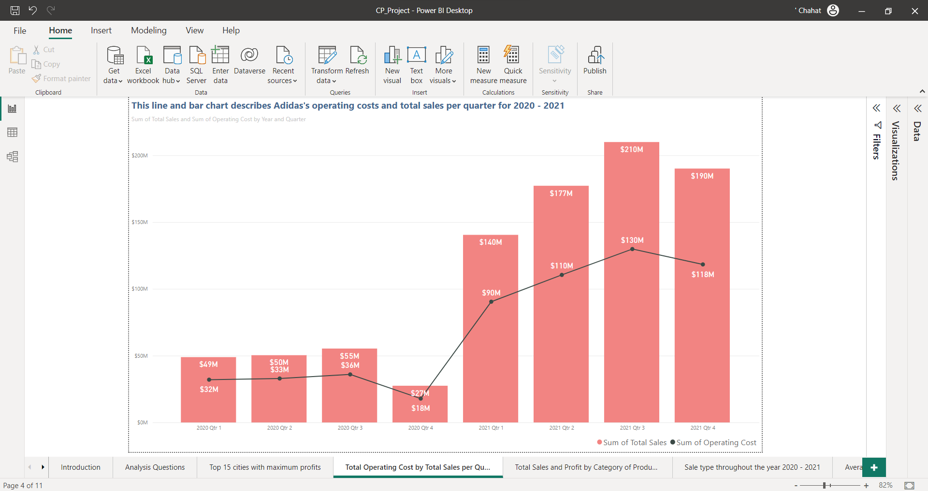

Figure 17

This line and bar chart describes Adidas's operating costs and total sales per quarter for 2020 – 2021.

1. **Total Sales and Profit by Category of Products**

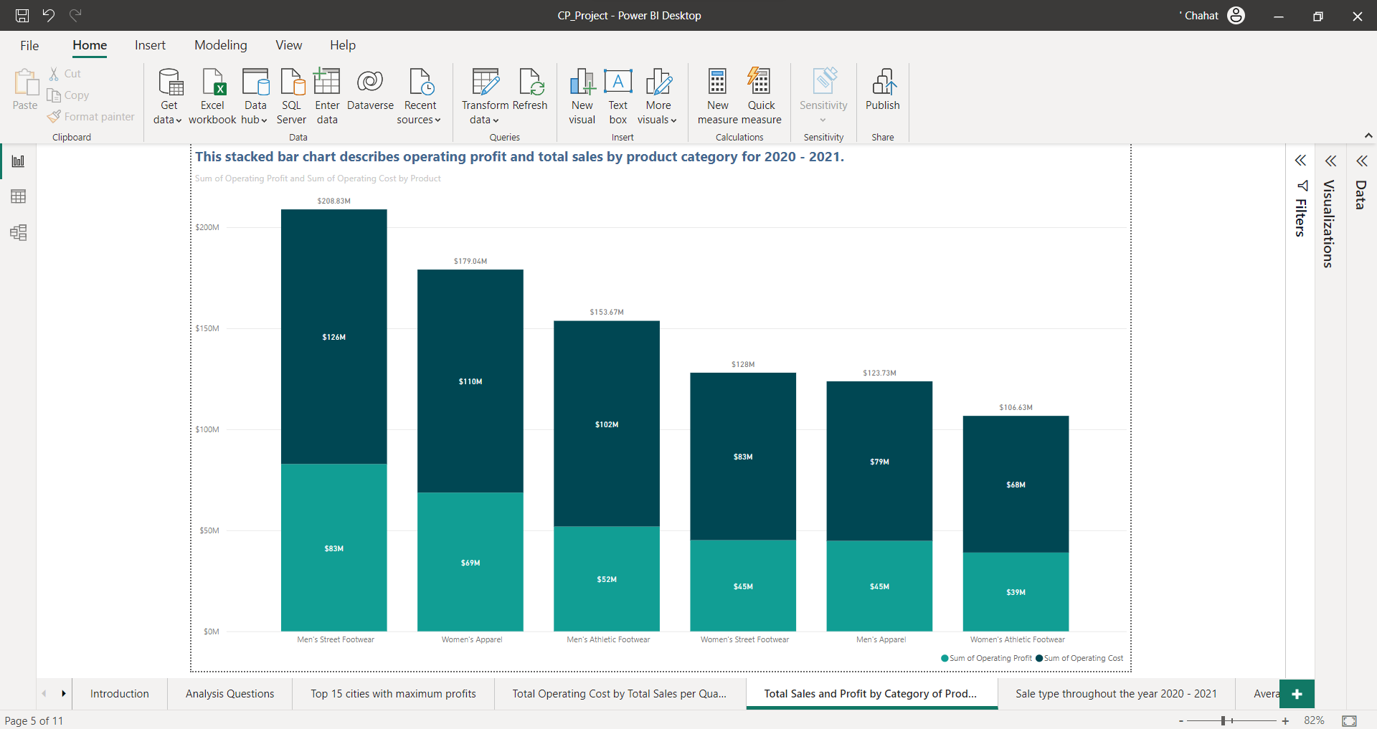

Figure 18

This stacked bar chart describes operating profit and total sales by product category for 2020 - 2021.

1. **Sale type throughout the year 2020 - 2021**

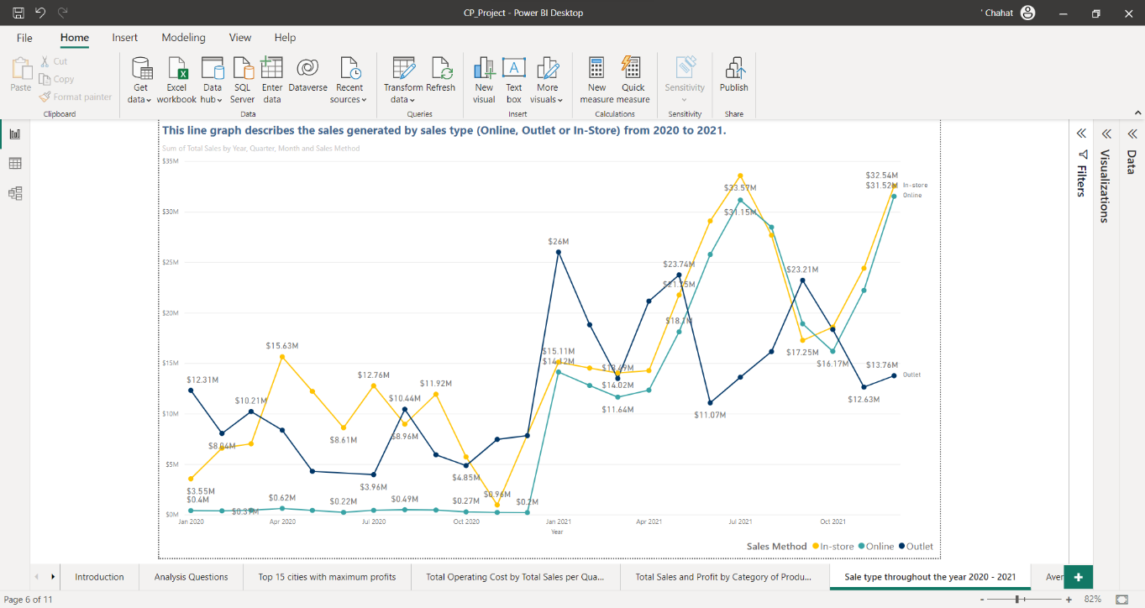

Figure 19

This line graph describes the sales generated by sales type (Online, Outlet or In-Store) from 2020 to 2021.

1. **Average cost per product category by retailer**

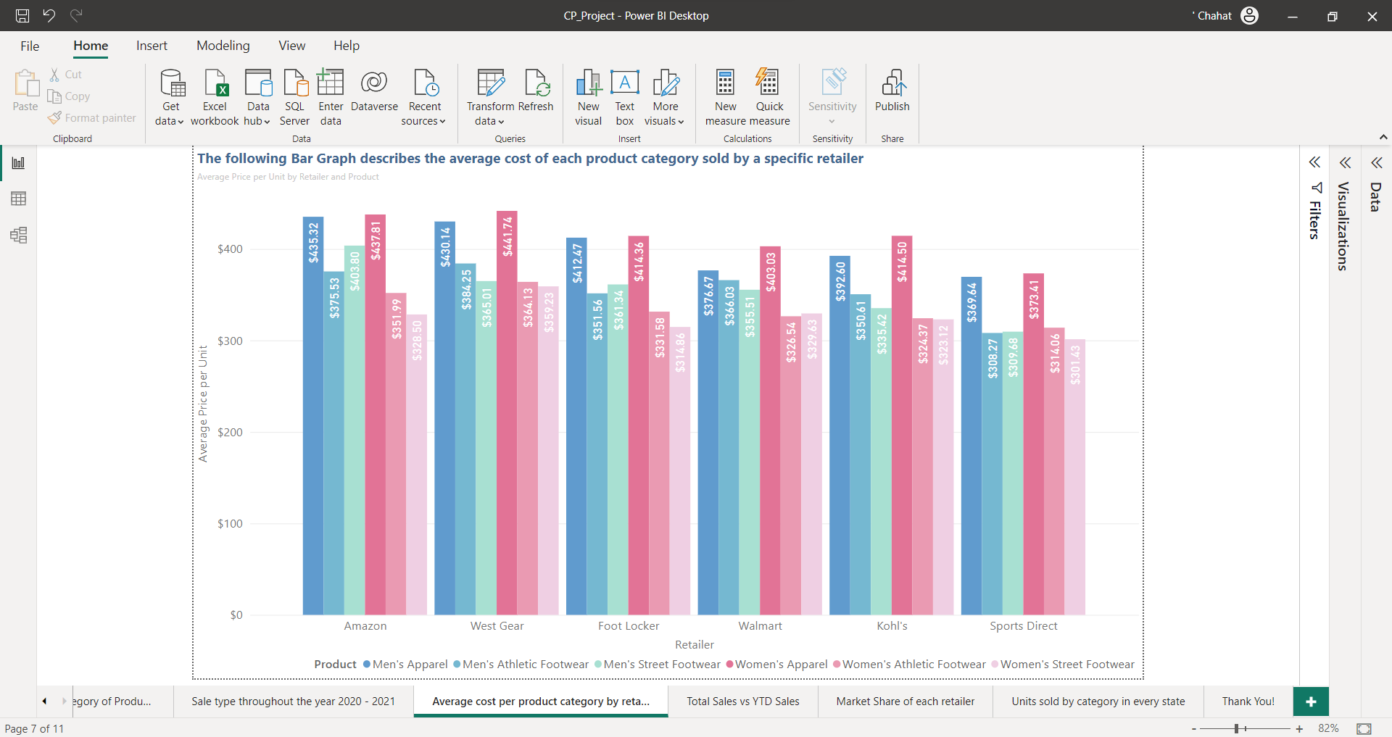

Figure 20

The following Bar Graph describes the average cost of each product category sold by a specific retailer.

1. **Total Sales vs YTD Sales**

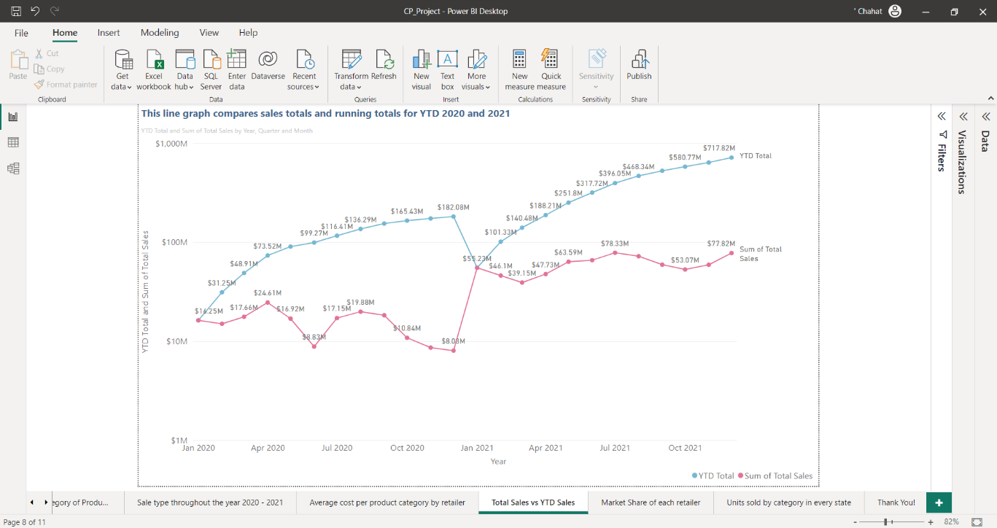

Figure 21

This line graph compares sales totals and running totals for YTD 2020 and 2021.

1. **Market Share of each retailer**

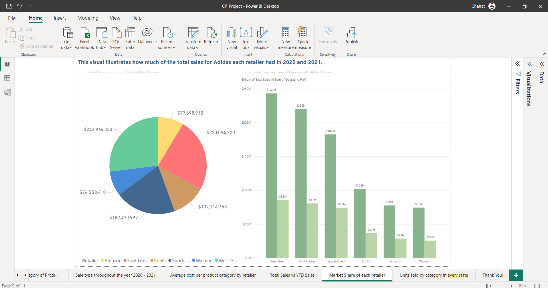

Figure 22

This pie chart illustrates how much of the total sales for Adidas each retailer had in 2020 and 2021.

1. **UNITS SOLD BY CATEGORY IN EVERY STATE**

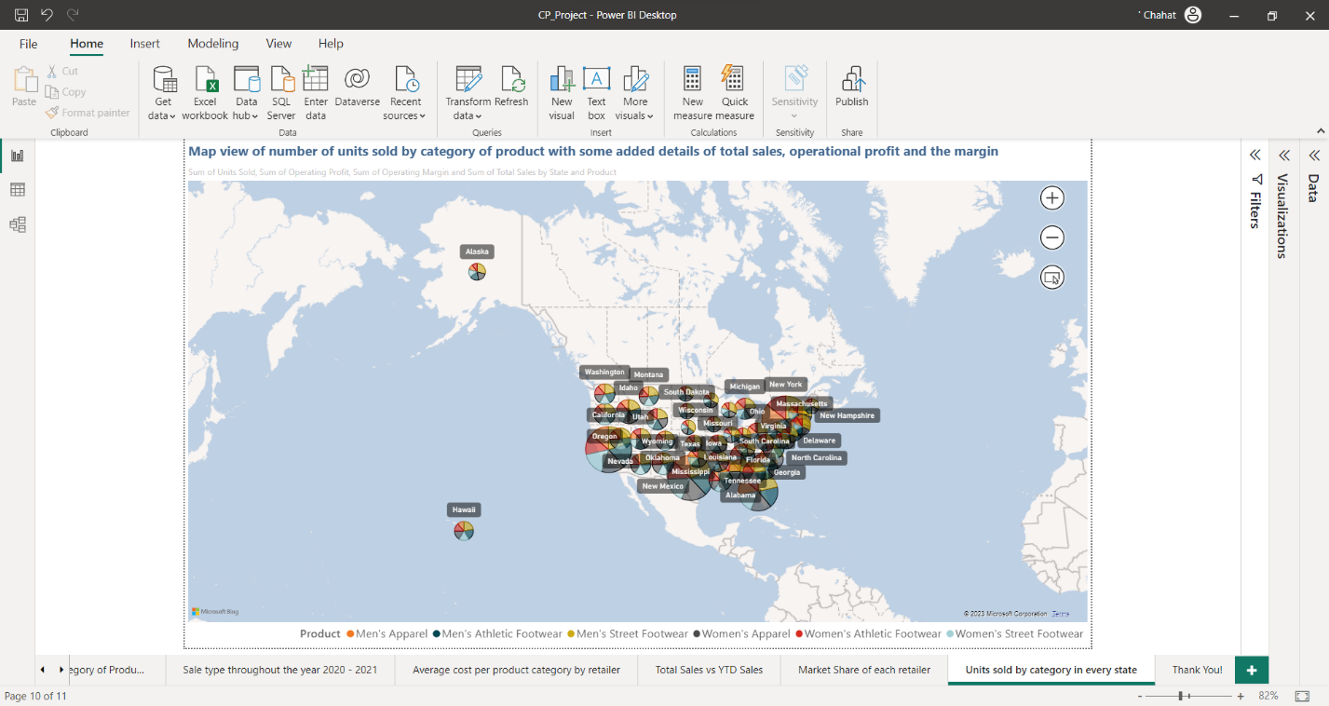

Figure 23

Map view of number of units sold by category of product with some added details of total sales, operational profit and the margin.